SQL MANDATORY ASSIGNMENT2 – SOLUTION

Dataset: Jomato
Tasks to be performed
- Create a user-defined functions to stuff the Chicken into ‘Quick Bites.’ E.g.: ‘Quick Chicken Bites.’
Query - Create Function QuickBites(@Stuffing Varchar(100))
Returns Varchar(180) as begin declare @Dish Varchar(180) Set @Dish = 'Quick' + @Stuffing + 'Bites' Return @Dish End
Go

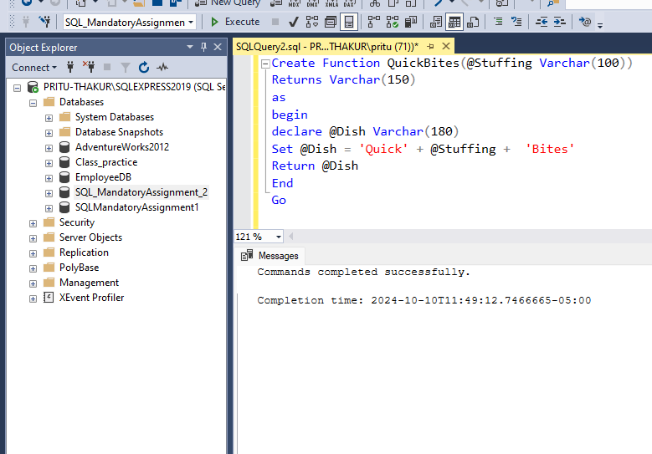
Query To check
SELECT dbo.QuickBites('Chicken')
SELECT dbo.QuickBites('Paneer')
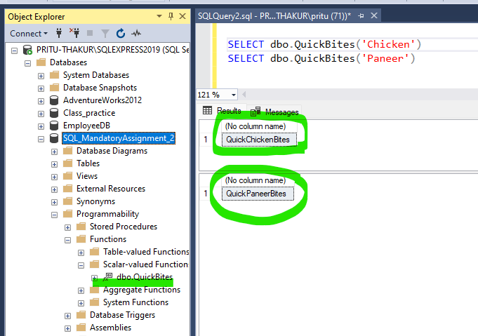

2.Use the function to display the restaurant name and cuisine type which has the maximum number of Rating.

Query: 1st Method when using No_of_Rating column for making the function from table.

CREATE FUNCTION MaxNo_of_Rating()
RETURNS TABLE
AS
RETURN
(
SELECT TOP 50
RestaurantName,
CuisinesType,
No_of_Rating
FROM
Jomato
ORDER BY
No_of_Rating DESC
)

Select * from MaxNo_of_Rating()

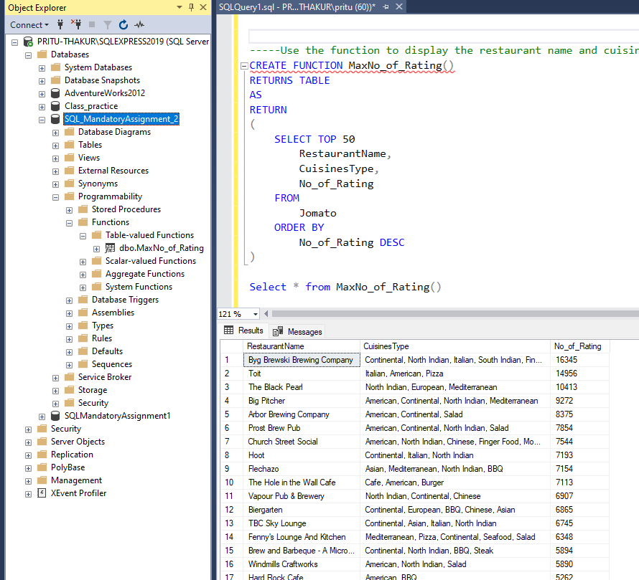

Query: 2nd Method – when No_of Rating Column is not used, but just Ratings are used to create the function.

Create function Maximum_rating()
returns table
return
Select RestaurantName,CuisinesType,Rating from Jomato
where Rating = (Select MAX(Rating) from Jomato)

Select * from dbo.Maximum_rating()
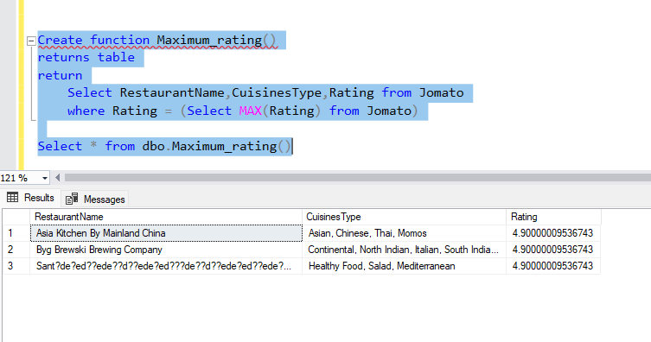

3.Create a Rating Status column to display the rating as ‘Excellent’ if it has more the 4 start rating, ‘Good’ if it has above 3.5 and below 5 star (writing query assuming this to be 4)rating, ‘Average’ if it is above 3 and below 3.5 and ‘Bad’ if it is below 3 star rating.

Query: SELECT
RestaurantName,CuisinesType,Rating,
CASE
WHEN Rating > 4 THEN 'Excellent'
WHEN Rating > 3.5 AND Rating <= 4 THEN 'Good'
WHEN Rating > 3 AND Rating <= 3.5 THEN 'Average'
WHEN Rating < 3 THEN 'Bad'
END AS Rating_Status
FROM [dbo].[Jomato]
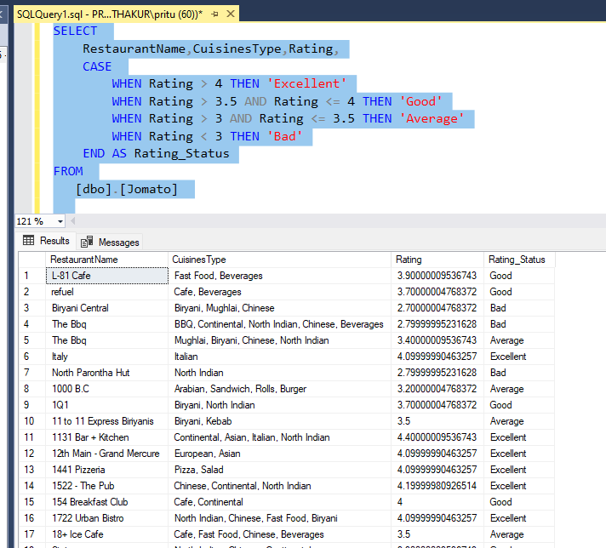

4. Find the Ceil, floor and absolute values of the rating column and display the current date and separately display the year, month name and day.
Query: SELECT
RestaurantName,Rating,
CEILING(Rating) AS Rating_Ceil,
FLOOR(Rating) AS Rating_Floor,
ABS(Rating) AS Rating_Absolute,
GETDATE() AS 'Current_Date',
YEAR(GETDATE()) AS Year,
DATENAME(MONTH, GETDATE()) AS Month_Name,
DAY(GETDATE()) AS Day
FROM
Jomato;
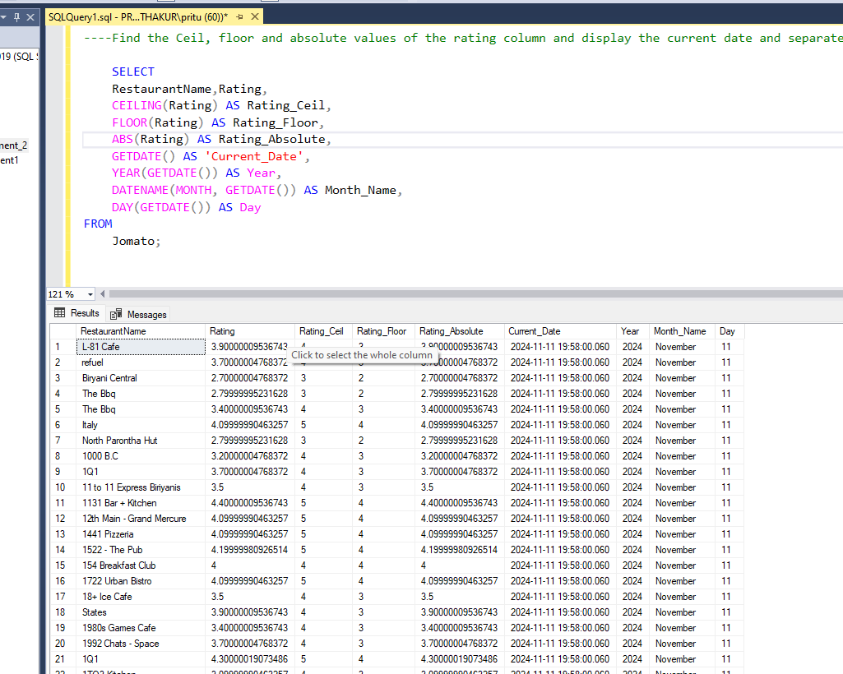

5. Display the restaurant type and total average cost using rollup.
Query: SELECT RestaurantType,
SUM(AverageCost) AS TotAvgCost
FROM Jomato
GROUP BY
ROLLUP(RestaurantType)
